Project Design Phase-II
Data Flow Diagram & User Stories

Date | 11 february 2026
Team ID | LTVIP2026TMIDS41011
Project Name | Visualization Tool for Electric Vehicle Charge and Range Analysis
Maximum Marks | 4 Marks

Data Flow Diagrams:
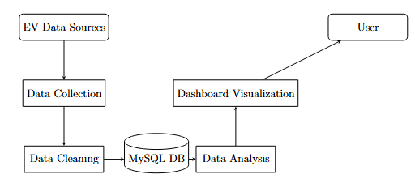
User Stories
Use the below template to list all the user stories for the product.
User Type | Functional Requirement (Epic) | User Story Number | User Story / Task | Acceptance Criteria | Priority | Release
Customer (Mobile User) | Registration | USN-1 | As a user, I can register for the application by entering my email, password, and confirming my password. | I can access my account / dashboard | High | Sprint-1
Customer (Mobile User) | Registration | USN-2 | As a user, I will receive confirmation email once I have registered for the application | I can receive confirmation email & click confirm | High | Sprint-1
Customer (Mobile User) | Registration | USN-3 | As a user, I can register for the application through Facebook | I can register & access the dashboard with Facebook login | Low | Sprint-2
Customer (Mobile User) | Registration | USN-4 | As a user, I can register for the application through Gmail | I can register & access dashboard using Gmail login | Medium | Sprint-1
Customer (Mobile User) | Login | USN-5 | As a user, I can log into the application by entering email & password | Dashboard opens successfully after login | High | Sprint-1
Customer (Mobile User) | Dashboard | USN-6 | As a user, I can view EV analytics dashboard | Charts and data load correctly | High | Sprint-1
Customer (Mobile User) | Dashboard | USN-7 | As a user, I can filter EV data | Filtered results display correctly | Medium | Sprint-2
Customer (Mobile User) | Dashboard | USN-8 | As a user, I can download reports | Reports download successfully | Medium | Sprint-2
Customer (Web User) | Dashboard | USN-9 | As a web user, I can view EV analytics on web portal | Data loads correctly on web dashboard | Medium | Sprint-2
Customer Care Executive | Support | USN-10 | As a support executive, I can view customer queries | I can see all user queries | Medium | Sprint-2
Customer Care Executive | Support | USN-11 | As a support executive, I can respond to customer issues | Responses are sent successfully | Medium | Sprint-2
Administrator | Data Management | USN-12 | As an admin, I can upload EV datasets | Data uploads successfully | High | Sprint-1

